PHOTOGRAPH

APPLICATION FORM

MASTER OF AUTOMOTIVE ENGINEERING
Years 2023 - 2025

To be submitted till the 1st May 2023, to the one of the partner universities

CTU in Prague, www.prihlaska.cvut.cz
HAN University of Applied Sciences, K. Bouwman, P.O.Box 2217, Arnhem, NL-6802 CE, The Netherlands
ENSTA Bretagne, Y. Marco, 2 rue Francois Verny, Brest, F-29806, France
TU Chemnitz, Alternative Fahrzeugantriebe, Prof. T. von Unwerth, 09107 Chemnitz, Germany
ITB, I. P. Nurprasetio, Jl. Ganesa 10, Bandung 40132, Indonesia

I. PERSONAL DATA

Family name | First name

Date of birth | Gender
 | M F

Nationality | Place of birth (city, country)

II. POSTAL ADDRESS
C/o

Street and house number

Area code | City | Country

Phone number | E-mail

Passport number Embassy location where the visa will be requested

III. EDUCATION

College and university
List, in chronological order, from the beginning of your higher education:
- the institutions where you have studied;
- the courses you have taken;
- the diplomas obtained with the corresponding marks and teacher appreciations;
- the breaks in your studies, if any.

Please enclose the photocopies of all reports and transcripts mentioned
Duration  From / till | Name of university and country | Subject and degree achieved | CGPA without bachelor thesis | CGPA for the whole bachelor studies | Date of award

IV. CHOICE OF STRUCTURE OF MASTER IN AUTOMOTIVE ENGINEERING

Cross in the following scheme the schools you would like to follow. Cross just one school for the first year and just one school for the second year. Czech and Slovak students willing to study on CTU should hand over also the Czech application (see web site of CTU, Faculty of Mechanical Engineering). Students of all nationalities willing to study at TU Chemnitz have to apply separately at TU Chemnitz for the study course “Automobilproduktion und -technik”. For more information please contact: martin.biak@mb.tu-chemnitz.de
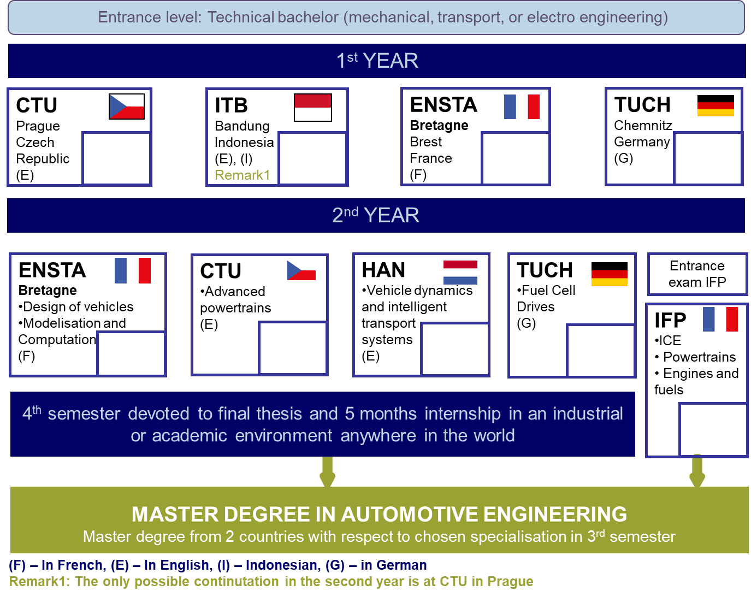

Are you applying for other postgraduate programmes?  Yes  No

If you do, which programmes? ...............................................................................................................

How did you get the knowledge about MAE programme? ……………………………………

V. LANGUAGES

What is your mother language?……………………..……………………….....................................

ENGLISH LEVEL

If you did not study on one of the partner universities, you have to state your TOEFL (minimum 550), Computerised TOEFL (minimum 213), Internet based TOEFL (minimum 79), TOIC (minimum 750) or IELTS (minimum 6) score and enclose the photocopy of the score report.

Score and type of evaluation ………………………….………………………………..…………………

If you studied on one of the partner universities enclose the statement of your teacher evaluating your knowledge of English language.
If you wish to follow universities, where the language of instruction is different than English, the English certificate is not requested.

FRENCH, GERMAN LEVEL and LEVEL OF OTHER LANGUAGES

If you want to study the Master course at ENSTA Bretagne or at TU Chemnitz, you should prove the knowledge of French or German, respectively. The minimum requirement for TU Chemnitz is level B2 according to the Common European Framework of Reference for Languages. Non-native speakers of German need to add a language certificate confirming the required language competence to the application file (DSH-1, DSH-2, DSH-3, TestDaF (Stufe 3), ZOP, KDS, GDS, DSD II, FSP, Goethe-Institut Zeugnis min B2).

Please indicate your level of skills in the languages listed below (from 0 to 5; 0 = no knowledge, 5 = excellent):

 | ENGLISH | FRENCH | GERMAN | CZECH | DUTCH
Reading comprehension
Conversation
Technical language

VI. INTEREST IN THIS PROGRAM

Please answer this question with a separate letter - one page (Statement of purpose) indicating your motivations and especially:

- the reasons for which you are considering to study Automotive Engineering;
- the reasons of your choice of schools for the first and second year;
- how you consider this program in view of your career.

VII. FINANCIAL AID

Please indicate your financial support for the duration of the program.

Have you applied for a scholarship ?  Yes  No

If you have, indicate the institution you have contacted………….…………….……………..……………………….

VIII. ACADEMIC OR INDUSTRIAL REFERENCES

Provide the names and complete contact information of your two referees knowing your work and ready to evaluate your study capabilities, that the admission commission can eventually contact them for further information.

 | 1st Referee | 2nd Referee
Name
Title
Institute/Company
Address
Country
Telephone
Fax
E-mail

I certify that the information given above is accurate. All the documents required are enclosed. I am aware that if any incorrect data was to be found, my application could be rejected or studies interrupted without warning.

City , date Signature

CHECK LIST
Your application file must include the following documents:
 Statement of purpose (one page maximally)
 CV
 Officially verified copy or original of transcript of records you followed in your university of origin (if the document is not delivered in English then the sworn translation into English should be submitted also).
 Filled self-assessment table of your knowledge in mathematics, mechanics, thermodynamics and technical drawings
 Officially verified and stamped with Apostille copy of your diplomas (if the diploma is not delivered in English then the sworn translation into English should be submitted also)
  Photocopy of English proficiency certificate. If the language of instruction of the universities of the first and second year is not English, then the respective language certificate has to be provided. When coming from partner university the certificate from language teacher from your university of origin is sufficient.
  Copy of passport

For emergency cases, please provide a contact to your close family.
Name
e-mail/Phone
Language |  | English | French | German | Dutch | Czech | Russian
If you have good friend or family member in town/country, where you will study MAE, please provide the name and contact (for emergency cases only)
Name & contact

